What is Science?
Day 2: Lesson Quiz
Choose the letter of the best answer.

1. Which is a possible scientific explanation for a temporary decrease in sunlight for a 30-minute period?
A. The moon was passing between the sun and Earth.
B. An airplane was flying overhead and blocked the light from the sun.
C. There are variations in the amount of light produced by the sun.
D. A sudden change in temperature increased the density of the atmosphere.
2. A friend reads in a book that a piece of black paper will get warmer in sunlight than a piece of white paper. Which of these is a scientific reaction to this information?
A. Accept the statement as true because your friend knows about science.
B. Design an experiment to show whether the statement is correct or incorrect.
C. Believe the statement because it was written in a book, so you can trust it to be true.
D. Tell your friend that the statement makes no sense.

3. Look at this setup for a scientific investigation.
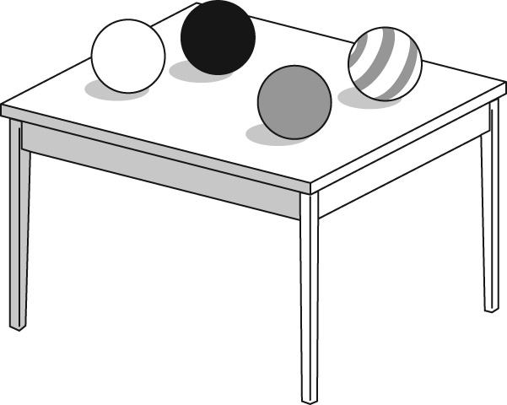
Which scientific question could you answer using only these objects?
A. What is the mass of each ball?
B. Which ball will bounce highest if it rolls off the table?
C. From what material is each of the balls on the table made?
D. How long will it take each ball to fall from the table to the floor?
4. A scientist finds a petri dish that had been used in an experiment several days earlier. The petri dish had not been cleaned after the experiment. In the dish, the scientist discovers a bacterial culture that she had not seen during the experiment. She wants to investigate whether the bacteria developed from the material left from the earlier experiment. Which of the following is a way for her to begin testing?
A. Take a sample of the bacteria and grow it in an incubator.
B. Gather dirty petri dishes from other labs to see if they grow the same bacteria.
C. Check all the clean petri dishes for the new bacterial culture.
D. Run the original experiment again, do not clean some of the petri dishes, and see if the same bacterial culture grows in the dirty petri dishes.
5. Ancient peoples noticed that when meat was a few days old, maggots appeared on it. They thought that the maggots came from the meat. During the 1600s, an Italian physician named Francesco Redi developed a theory that the maggots came from flies that laid eggs on uncovered meat. He tested his idea by keeping flies away from meat. Maggots did not appear on the meat that Redi protected from the flies. Which of the following best shows that Redi was thinking like a scientist?
A. Before he did his experiments, Redi said he would not change his mind about his theory.
B. Redi made an explanation that he was able to test.
C. Before he had experimental results, Redi said that the old theory was not correct.
D. Redi did not do experiments; he used only logic.

